LOCATION : NATIONWIDE
DATE : 01.12.2017
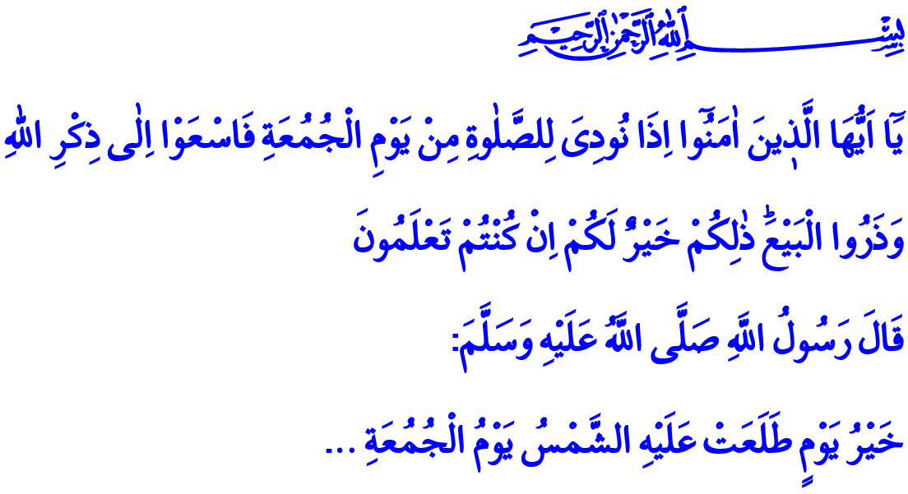FRIDAY: THE BEST DAY ON WHICH
THE SUN HAS RISEN
Honorable brothers and sisters who gathered together in this holy mosque to perform the Friday prayer which is among the principles of Islam. May your Friday be blessed, and your day be beneficial!
It was a Friday, just like this. Our Prophet (pbuh) finally got close to Medina after the arduous journey of hegira that lasted for days. When he reached the place called “Ranuna” near Medina, the time for Friday prayer had come. The Messenger of Mercy delivered the khutba to the crowd who came to welcome him with excitement. He became the imam for the first Friday prayer. Our Prophet (pbuh) said this to us all in that khutba through his companions: “Now then, O people, advance good works for yourselves before you die. You know, by Allah, each one of you will leave this world behind. Then Allah will ask you: ‘Did my Messenger not come to you and inform you of My Message? Did I not bestow on you property and graces? So, what have you advanced for yourself?’... Whoever can protect himself from the Hell-Fire, let him do so in his power. Let him do it with half a date, or even just with a good word.”
Brothers and Sisters!
Today is Friday. Today is the Eid of our week. We live each Friday with a great joy. We experience a joy and excitement that is impossible to describe. Because Friday is an exceptional day that allows us to rejuvenate weekly and hold on to life again. Friday is the day when our souls find peace after getting suffocated by all kinds of complexities of life. It is the period when our hearts become clear and find themselves after getting exhausted by all kinds of difficulties.
Dear Brothers and Sisters!
Our Lord Almighty enjoins in the Quran: “O you who believe! When the call is proclaimed for the prayer on the day of Friday, come to the remembrance of Allah and leave off business (and every other thing), that is better for you if you did but know!” In this respect, Friday is the name of us standing before Allah Almighty, free from everyday occupations, from all kinds of worldly concerns. Just as we show our submission and loyalty to our Lord in our prayers five times a day, we strengthen this determination of ours in the Friday prayer. We renew our oath of servitude every Friday. We offer our prayers and good deeds that we made during the week once again to our Lord in this meeting.
Honorable Brothers and Sisters!
Friday is the time of accounting for us. It is the moment of reviewing our course and clearing ourselves from the sins that we knowingly or unknowingly committed. Friday is just the right time for us to take refuge in Allah’s limitless mercy and compassion knowing that the prayers would not be turned down.
Friday is the day when we shout out loud our unity and solidarity, brotherhood and friendship. We, young and old, man and women, gather together in mosques in the Friday prayer with the same faith, same intention and the same ideals. We listen to the khutbas delivered from these minbars that are the seats of our Prophet. We socialize once again, in our joy and sadness. We all together experience the joy of being a servant of Allah, being brothers and sisters, sharing and cooperation, with our hearts and souls.
Honorable Believers!
To quote our Prophet, Friday is the best day on which the sun has risen. Therefore, Friday is one of the symbols of our Holy Religion of Islam. Friday is mercy. Friday is blessing. Friday is peace. The fact is, every day, every second that we have is precious in our faith. Because Allah Almighty created the time and granted it as a blessing to us. And what’s important before Allah is not how we refer to time or what we call the days; it is how we put our time to good use. It is whether we spent every breath in accordance with our Lord’s countenance. It is whether we transformed our short life into an eternal reward or not.
Dear Brothers and Sisters!
The expression of “Black Friday” we have heard often recently disturbed us all as believers. Because in our faith, all days belong to Allah. The morning of each day is the awakening for a bright future. Such disrespectful expressions and approaches that target the symbol of a faith and disregard its members have no place in our tradition and customs. The fact that a sacred concept of a religion is abused as a means of limitless consumption is just unacceptable.
Brothers and Sisters!
As believers, our task against the face of such efforts that could create a negative perception in the minds is to hold fast to our faith and values. The most important duty we have for the humanity is to represent and convey correctly the Quran that is our guide to salvation, and Our Prophet who is the Mercy to the Worlds, to the best of our abilities. Let us not forget that the help of Allah will be with us as long as we strive for this cause.

Ibn Hisham, Seerah, III, 30.
Al-Jumu’ah, 62/9.
Sahih Muslim, The Book of Prayer - Friday, 18. Written by: General Directorate of Religious Services

